

Name: _____________________________

Teacher : ___________________________

Science Class : ______________________

YEAR 10 SCIENCE
2017

Time allowed for this paper
Reading time before commencing work: Working time for the paper:

5 minutes
55 minutes

Materials required/recommended for this paper

To be provided by the supervisor:
Multiple-choice Question Booklet
Question/Answer Booklet
Data Sheet

Students to provide:
Standard items: pens (blue/black preferred), pencils (including coloured), sharpener, eraser, ruler, highlighters

Special items: non-programmable calculator

Important note to students:
No other items may be taken into the examination room. It is your responsibility to ensure that you do not have any unauthorised notes or other items of a non-personal nature in the examination room. If you have any unauthorised material with you, hand it to the supervisor before reading any further.

Structure of this paper

Section | Number of questions available | Number of questions to be answered | Suggested working time  (minutes) | Marks available
Section One:  Multiple-choice | 15 | 15 | 15 | /15
Section Two:  Short answer | 16 | 8 | 20 | /27
Section Three:  Extended answer | 5 | 2 | 20 | /20
 |  |  |  | /62

Instructions to candidates

1. Answer the questions according to the following instructions.

Section One
Answer all questions on the front of the separate Answer Booklet provided. For each questions put a cross (X) in the box to indicate your answer. Use only a blue or black pen to mark the boxes. If you make a mistake, shade that square then put a cross on your new answer. Do not erase or use correction fluid/tape. Marks will not be deducted for incorrect answers. No marks will be given if more than one answer is completed for any question.

Sections Two and Three
Write your answers in the Question/Answer Booklet.

2. When calculating numerical answers, show your working or reasoning clearly. Express numerical answers to the appropriate number of significant figures and include appropriate units where applicable.

3. You must be careful to confine your responses to the specific questions asked and to follow any instructions that are specific to a particular question.

4. Remember to use pencil and ruler for all diagrams. Include clear labels and titles where appropriate.

Multiple Choice Section. Answer in the booklet provided. 15 marks.

- An element is a:

- Substance that contains molecules
- Pure substance made up of only one type of atom
- Pure substance made up of two types of atoms
- Substance that contains no bonded atoms

- An atom has a mass number of 27. It therefore has:

- 13 protons, 14 neutrons and 14 electrons
- 13 protons, 14 neutrons and 13 electrons
- 14 protons, 14 neutrons and 14 electrons
- 13 protons, 13 neutrons and 13 electrons

- Which of the following shows the correct conjugate base pairs?

- thymine and guanine
- adenine and guanine
- cytosine and adenine
- cytosine and guanine

- Which of the following statements about the number of daughter cells produced is CORRECT?

- mitosis = 4 daughter cells, meiosis = 2 daughter cells
- mitosis = 1 daughter cell, meiosis = 2 daughter cells
- mitosis = 1 daughter cell, meiosis = 4 daughter cells
- mitosis = 2 daughter cells, meiosis = 4 daughter cells

- What is the name given to an individual whose alleles are the same for a characteristic?

- heterozygous
- homozygous
- monohybrid
- homologous

- Which of the following best describes the energy changes occurring when an apple falls from a tree branch to the ground below?

- gravitational potential→kinetic→sound
- gravitational potential→elastic potential→sound
- kinetic→sound→gravitational potential
- elastic potential→sound→kinetic
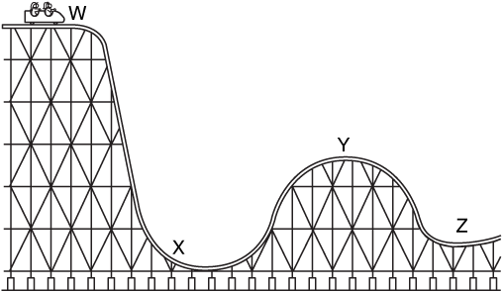
Questions 7 and 8 refer to the diagram of a rollercoaster below.

- At which point on the rollercoaster does the cart have the most gravitational potential energy?

- W
- X
- Y
- Z

- At which point on the rollercoaster does the cart have the most kinetic energy?

- W
- X
- Y
- Z

- Which of the following is TRUE regarding kinetic energy?

- The greater an object’s mass, the greater its kinetic energy
- The greater an object’s speed, the greater its kinetic energy
- An object at rest has no kinetic energy
- All of the above

- The kinetic energy of a ball rolling down along a table can be calculated using the formula Ek=½mv^{2.} ,if the mass of the ball is 1kg and the velocity is 2ms⁻¹: What kinetic energy does the ball have?
- 2 ms⁻¹
- 1 ms⁻¹
- 0.5 ms⁻¹
- 3. ms⁻¹

- What is the difference between displacement and distance?

- distance is the meters travelled plus the direction.
- there is no difference.
- displacement must include the direction travelled.
- displacement is only the meters travelled.

- Speed is measured using

- seconds.
- kmh⁻¹ only.
- ms⁻¹.
- Newtons

Use the example given to answer question 13 and 14.
A tiger runs 500m east, then turns and runs 200m west. If the total journey took 100s:

- His distance travelled was

- 700m.
- 500m.
- 200m.
- 100

- His displacement was:

- 300m.
- 300m east.
- 2 ms⁻¹.
- 500m.

- To convert 12 minutes to seconds you would:

- divide by 60
- divide by 36.
- times by 3.6.
- times by 60

End of Section One



SEMESTER 2 2017
YEAR 10 SCIENCE EXAM
ANSWER BOOKLET

NAME:

FORM: DATE:

Multiple Choice Short Answer Extended Answer Total

/15

/63

/20

/113

SECTION ONE: Multiple choice answers
Cross (X) through the correct answer.

1 | a | b | c | d
2 | a | b | c | d
3 | a | b | c | d
4 | a | b | c | d
5 | a | b | c | d
6 | a | b | c | d
7 | a | b | c | d
8 | a | b | c | d
9 | a | b | c | d
10 | a | b | c | d
11 | a | b | c | d
12 | a | b | c | d
13 | a | b | c | d
14 | a | b | c | d
15 | a | b | c | d

Section Two: Short answer ( marks)

Question 16

Classify the following as situations in which forces are balanced or unbalanced.

a. A motor bike accelerating away from traffic lights. (1 mark)

b. A car travelling at a constant 100 kmh⁻¹ straight down a freeway. (1 mark)

Question 17

A short form of Newton’s First Law is inertia. Explain what inertia is and how it relates to the mass of an object. (2 marks)

Question 18

Mr Miles was doing time-trials on his bike around a 400 metre horizontal track.

(i) He took 32 seconds to travel 400 m. What was his average speed? (3 marks)

(ii) Compare the forward force on the bike with the backward force on the bike when Mr Miles was travelling at a constant speed. (1 mark)

Question 19

You are sliding down a hill after falling off your bike. The road is applying of force of -90 N (due to friction) on you to slow you down. If you have a mass of 50 kg, what was your acceleration?
(3 marks)

STOP: Read the following instructions carefully.
- Identify which module you completed at the beginning of Term 3 (not the one you are currently working through)

- If you completed Module 1 SPORT SCIENCE, answer questions 20 – 23 ONLY.

- If you completed Module 1 FORENSIC SCIENCE, answer questions 24 – 27 ONLY.

- If you completed Module 1 EVOLUTION, answer questions 28 – 31 ONLY.

Identify the module you completed:

I completed Module 1:

I am answering questions to ONLY.

SPORTS SCIENCE

Question 20

Describe the three main functions of the cardiovascular system . (3 marks)

Question 21
How is cardiovascular endurance measured? (4 marks)

Question 22

List 3 major functions of the skeleton. (3 marks)

Question 23
Compare and contrast the three main types of joints in humans. (6 marks)

FORENSIC SCIENCE

Question 24

Explain the principle of Locard’s Exchange Theory. (2 marks)

Question 25

Define the term “contact trace” and provide three examples of this type of evidence. (5 marks)

Question 26

Identify three ways that blood can be used to help solve a crime. (3 marks)

Question 27

Identify and describe some important characteristics of a good eye witness. (6 marks)

EVOLUTION

Question 28

Write the vocabulary terms which match the following definitions (4 marks)

Term | Definition
 | Burst of evolutionary change followed by periods of stability.
 | Slow evolutionary changes over a long period of time.
 | When two organisms evolve in response to the other.
 | Formation of a new species from a pre-existing species.

Question 29

Compare and contrast the processes of convergent evolution and divergent evolution, giving examples of each where appropriate. (4 marks)

Question 30 (3 marks)

Use the phylogenetic tree below to answer questions a) – c):

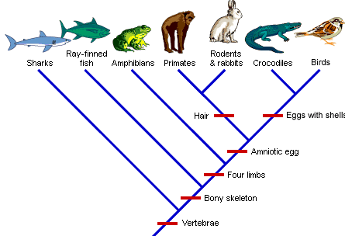

- Which organism diverged first?
- Who is most closely related to the primate?
- What do all of these organisms share?

Question 31
Field of Study | Evidence for Evolution
Paleontology
 | The locations of living things with similar characteristics points to divergent evolution.
Biochemistry
Embryology
 | Similar structures in unrelated organisms points to a common ancestor.
Complete the table by filling in the missing information: (5 marks)

End of Section Two
SECTION THREE: EXTENDED ANSWER SECTION (20 marks)

Question 32 The table below shows the speed of a cheetah starting at rest and then at 5 second intervals as it chases its prey.

Time in s | 5 | 10 | 15 | 20 | 25 | 30 | 35 | 40 | 45
Speed in ms⁻¹ | 6 | 14 | 27 | 27 | 27 | 20 | 12 | 3 | 0

- Draw a graph to represent the data in the table. (6 marks)
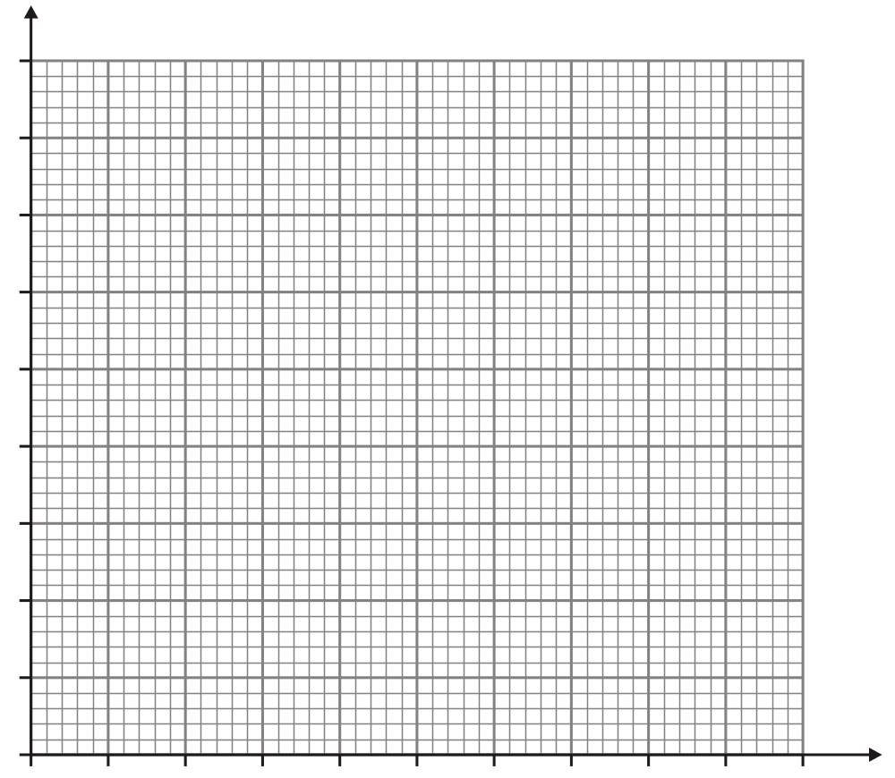

Use the information in the table and the graph to;

b) Write down the time intervals in which the acceleration of the cheetah was: (3 marks)

i. zero.

ii. positive.
iii. negative.

c) Calculate the acceleration of the cheetah between 25 and 40 seconds. (4 marks)

Question 33 (10 marks)

Select one (1) of the following questions to write your extended answer. Complete your answer in the spaces provided, including labelled diagrams where appropriate.

OPTION 1: Sport Science

The cardiovascular system plays a major role in transporting blood and essential components around the body. Compare and contrast the structure and function of the three types of blood vessels in the human body. Give detailed examples and labelled diagrams where appropriate.

OPTION 2: Forensic Science

It is your first day on the job as a Police Forensic Investigator and you are determined to impress your new boss. You are called to the scene of a robbery in a busy city mall.

Describe in detail the actions you would take from the moment you arrive at the scene.

OPTION 3: Evolution

Charles Darwin promoted the theory of natural selection in his studies of evolution.
Provide a definition for the term ‘natural selection’ and describe its principles by referring to how it would impact on a real species.

OPTION 3: Cosmetic Science

Australians spend over $100 billion a year on looking good, including treatments and products to make their hair look healthy and shiny. Name and describe the 3 layers of hair, including a clearly labelled diagram. Describe the cleaning process of shampoo and what effect the pH of your chosen product has on your hair.

Option number selected:

END OF EXAM

